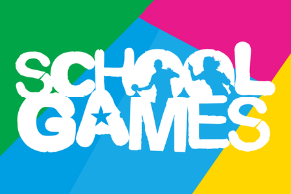
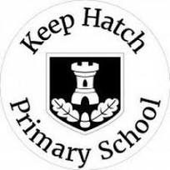
Keep Hatch’s
Sports Afternoon and Family Picnic
Years 3 - 6

Friday 4th July 2025

Sports Day will follow the same structure as last year. Please read the information below to remind yourself of the changes.
All children should come to school in their coloured House top, black shorts and trainers. They will be staying in their PE kits all day. Please do not park on the school site or Sainsbury’s car park. A programme and diagram of the Round Robin stations will be available on the website a week before the sports afternoon.

Sports Afternoon
Gates will be open from 12.15pm.
The races will begin at 12.30pm and finish at 3.20pm.
Order of the afternoon:
- Flat races
- Long distance races for children
who would like to participate
- Round Robin stations- on the field and
surrounding playgrounds. Please follow
your child/rens class to each station
- Children’s House relay
- Staff relay
- Parents’ relays
- Winning house presentations

Home-Time
Please allow children to be taken, by their teacher, back to their class and collected from classrooms as normal.
Family celebrations!
Please don’t forget that you are able to stay and enjoy a family picnic whilst soaking up the Keep Hatch community atmosphere from 3:20-4:30pm! We look forward to seeing as many of our Keep Hatch families as possible!



Health and Safety Information:
If it is sunny, we endeavour to keep the children in the shade as much as possible. However:
- Please ensure your child brings a hat to school.
- We advise any parents to apply sun protection to their child before school.
- If it is cool, please ensure your child has at least a jumper or cardigan to wear outside.
- If it is wet (or the grass is too slippery), the event will have to be cancelled.
- Please be reminded that any photography taken on the day should not be shared on social media.
Parent Information:
Children will be having an early lunch. Please provide an extra afternoon snack.
Please note there will be no hot lunches on this day. Packed lunches will be available for children entitled to free school meals.
Please use the outdoor toilet (next to the pool entrance). Please note there is only one toilet that can be used.
Please do not enter the school building for any other reason.
Please do not come onto the track or block the finish line during the races.
Please stand to the side when watching your child in the Round Robin stations. Children must stay with their class and teacher, and not be taken away from them.
Please be reminded that Keep Hatch is a no smoking site.

